# **Department of Computer Science and Engineering Islamic University of Technology (IUT)** A subsidiary organ of OIC

# 

# **Laboratory Report**

# CSE 4412 : Data Communication and Networking Lab

## 

## **Name: Maheen Mashrur Hoque Student ID: 190042148 Section: 1 (SWE) Semester: 4th Academic Year: 2021**

**Date of Submission: 9 Dec 2021**

### **Title:** Creating a Simple LAN (Local Area Network) in CISCO Packet Tracer.

### **Objective**:

1. Create a Simple LAN (Ring Topology) by connecting multiple end devices
2. Significance of IP address
3. Difference between Switch and Hub.

### **Devices/ software Used**:

1. Cisco packet tracer

### **Diagram of the experiment:**

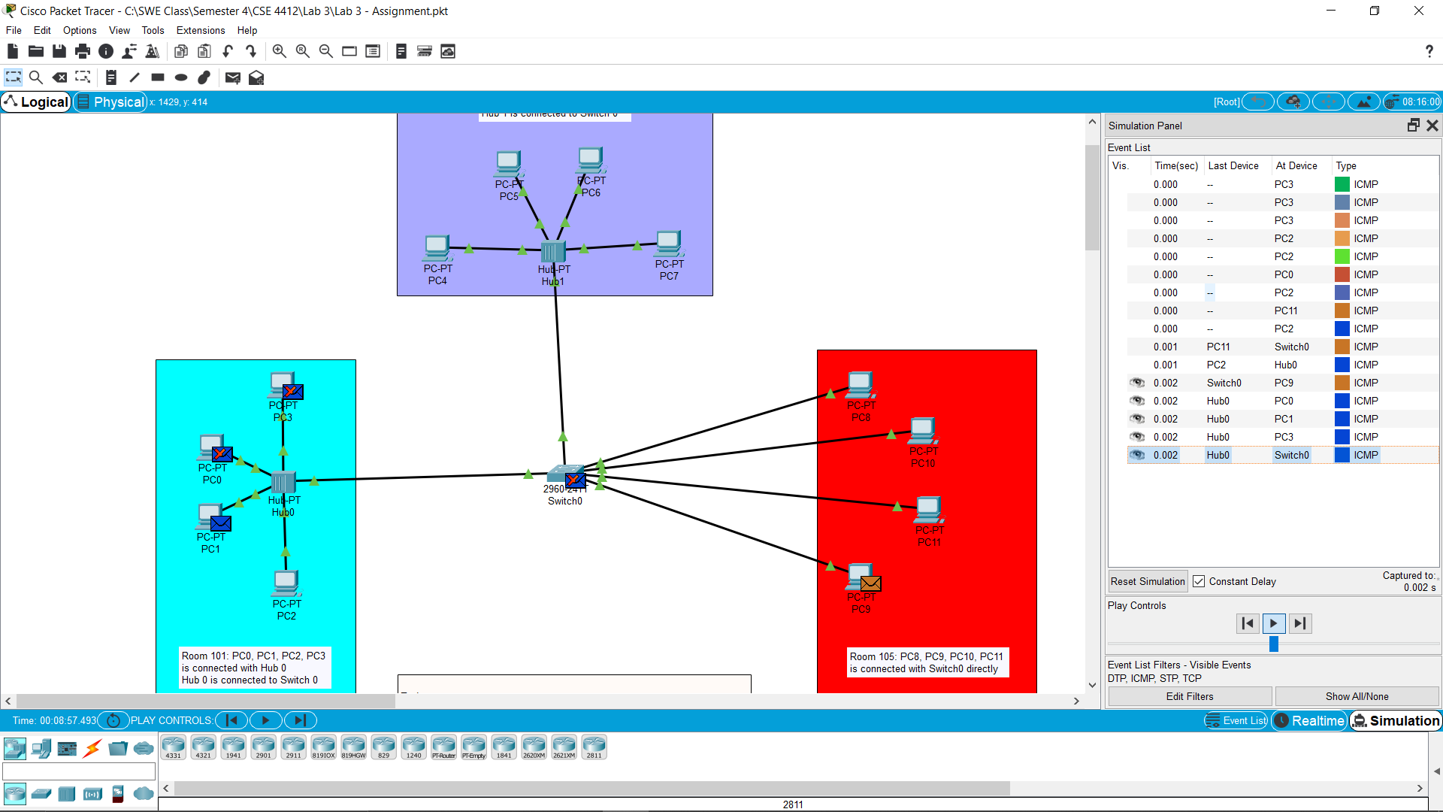

### **Working Procedure:**

1. The devices were connected according to the instructions given in the lab file, via the copper straight through cable.
2. The end devices were configured with an IP address. The network ID section of the IP were different for each section.
3. From the terminal of PC-9, a ping (as an ICMP packet) was sent to the device PC-11. Then, from the terminal of PC-2, a ping was sent to PC-1.

### **Observation**:

The observations of two events:

1. **Transfer from PC-2 to PC-1:**  
   1. PC-2 sends the ICMP packet to HUB-0.   
   2. The HUB-0 hub sends the packet to all devices connected with it. However, due to mismatch of IP, all device, other than the intended host, PC-1 rejects the package.  
   3. The PC-1 device sends back an ICMP response to PC-2, in the same manner as steps 1 and 2.
2. **Transfer from PC-9 to PC-11:**  
   1. PC-9 sends out the packet to the SWITCH-0.  
   2.The switch checks the MAC table for the destination’s MAC address. And then, sends the packet to the destination device, which in this case is PC-11.  
   3. PC-11, after receiving the packet, sends out an ICMP response to PC-9 in the same way as steps 1 and 2.

### **Challenges:**

1. Faced problem again when logging in.
2. The IP of each device had to be configured manually.

### 